1)Setup one master and two worker nodes in ansible

Ansible Setup: 1 Master + 2 Worker Nodes
We’ll create:
- 1 Ansible Master Node
- 2 Worker Nodes
- Passwordless SSH
- Inventory setup
- Test connection using ansible ping

Architecture
Node | Role
Master | Control Node
Worker1 | Managed Node
Worker2 | Managed Node

Prerequisites
Use:
- Ubuntu 22.04 OR Amazon Linux
- Minimum 3 EC2 instances or VMs
- All servers should communicate privately

STEP 1 — Launch 3 Servers
Create 3 EC2 instances.
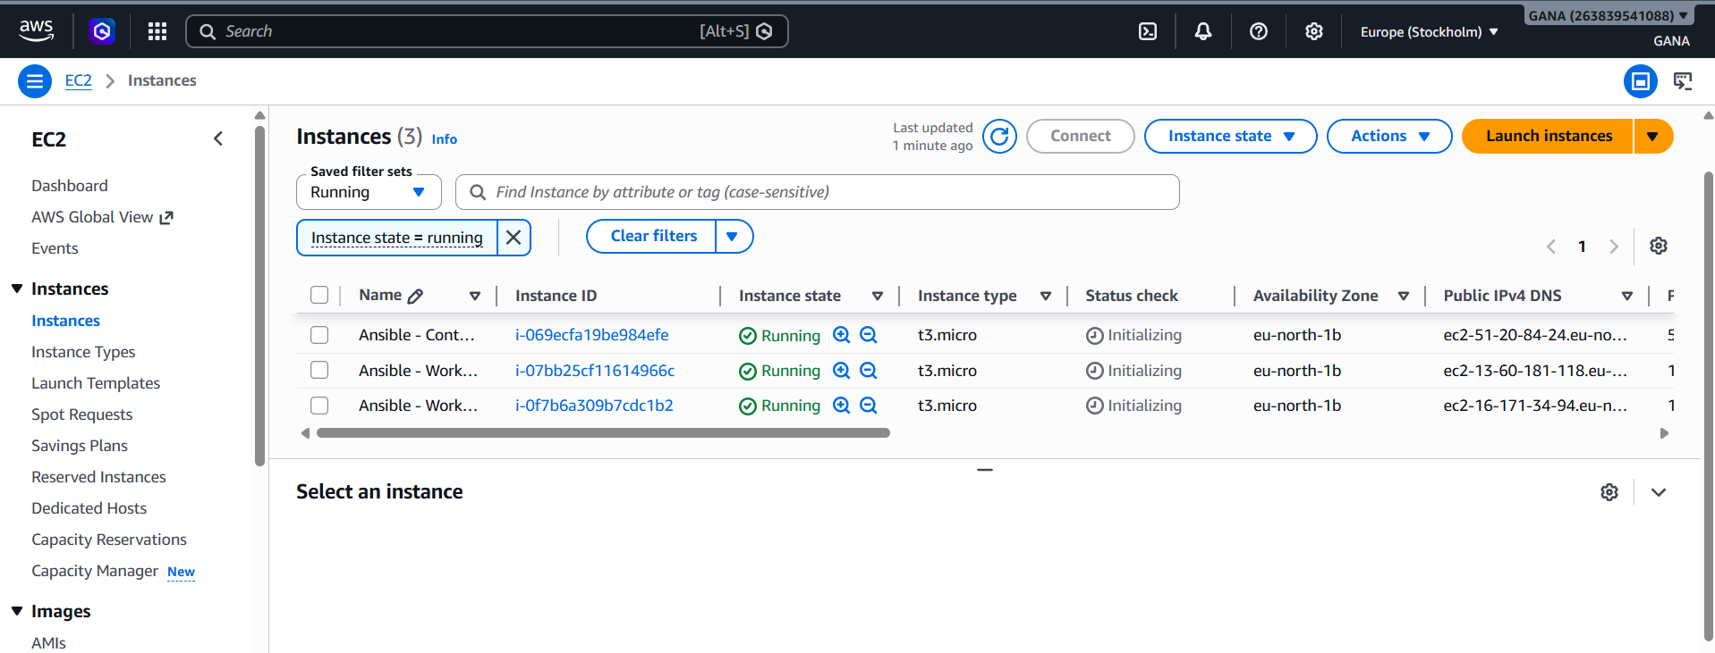

Example:
Server | Private IP
Master | 172.31.10.10
Worker1 | 172.31.10.11
Worker2 | 172.31.10.12

STEP 2 — Configure Security Group
Allow:
Type | Port
SSH | 22
Source:
- Your IP
- OR same security group

STEP 3 — Update All Servers
Login to all 3 servers.
Run:
sudo apt update -y
sudo apt upgrade -y
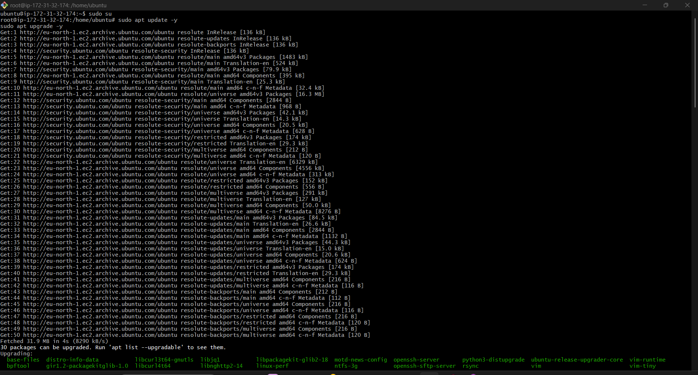
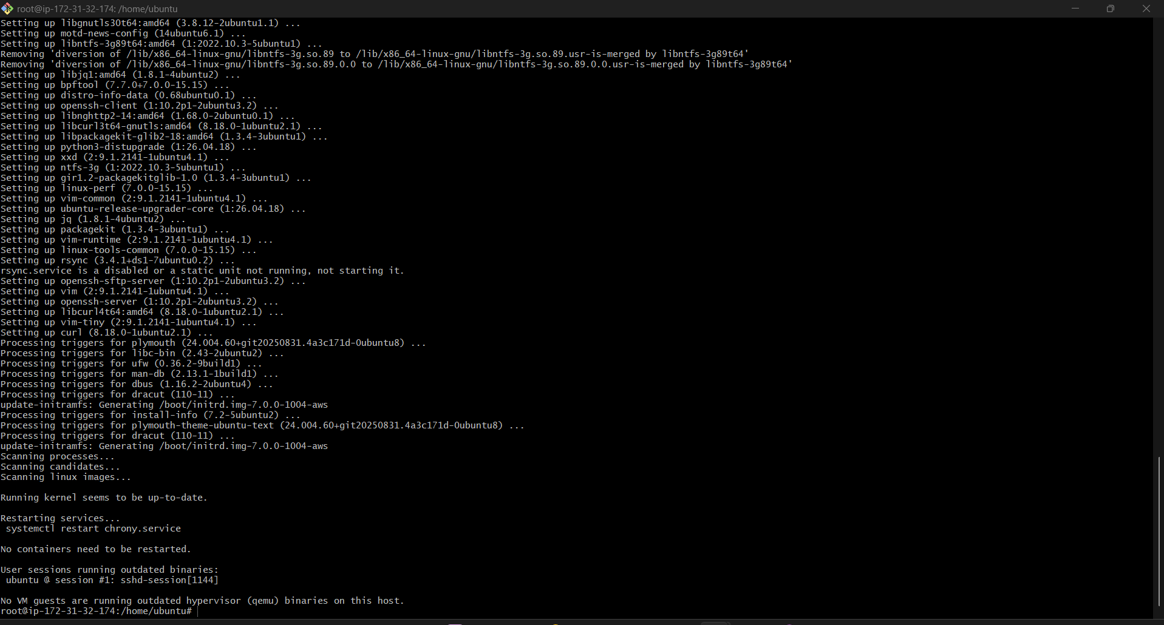
For Amazon Linux:
sudo yum update -y

STEP 4 — Set Hostnames
On Master
sudo hostnamectl set-hostname Ansible-Controller
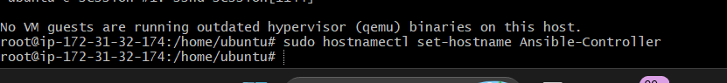
On Worker1
sudo hostnamectl set-hostname Ansible-worker1
On Worker2
sudo hostnamectl set-hostname Ansible-worker2
Reconnect SSH after changing hostname.
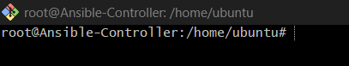
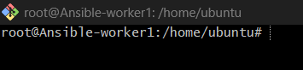
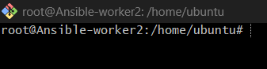

STEP 5 — Install Ansible on Master
Login to Master.
Ubuntu
sudo apt update -y
sudo apt install ansible -y
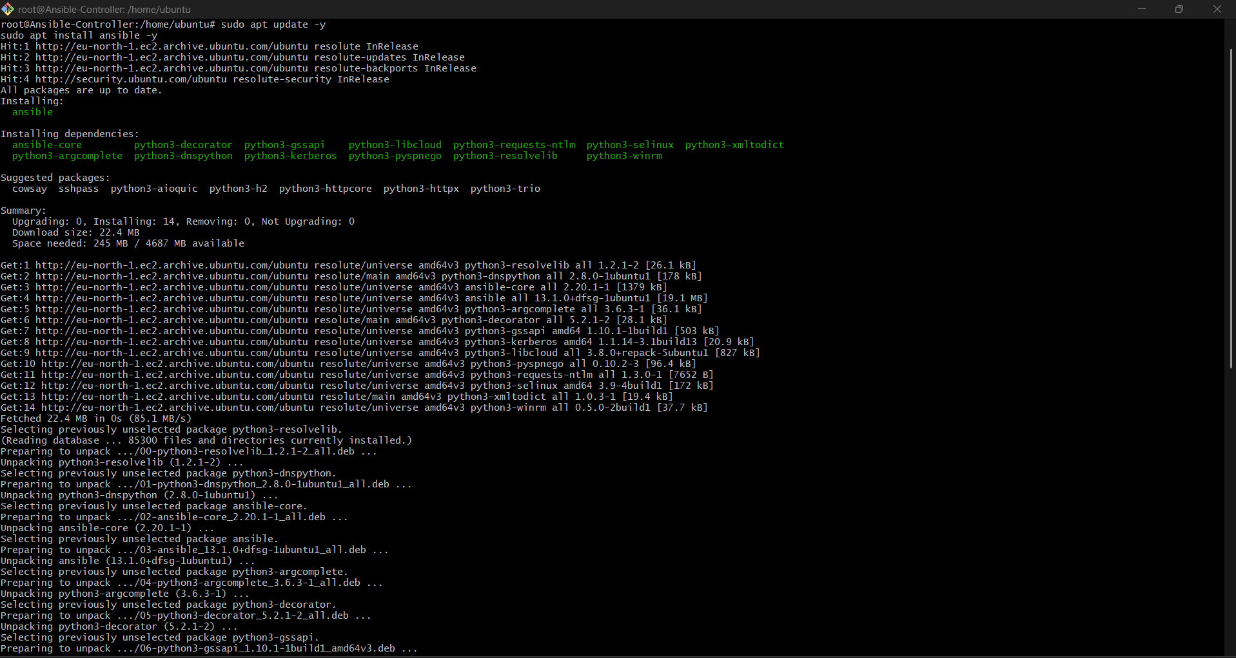
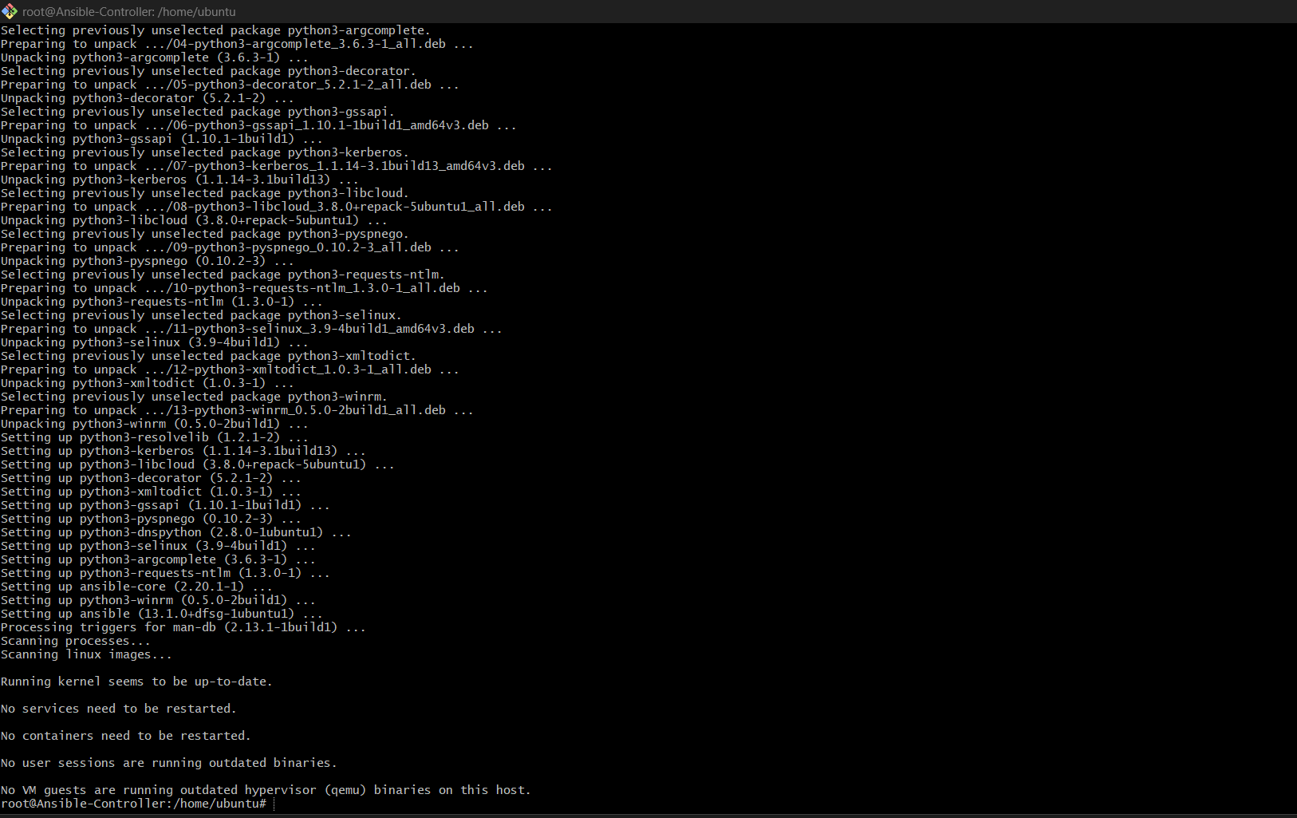
Amazon Linux
sudo amazon-linux-extras install ansible2 -y
Verify:
ansible –version
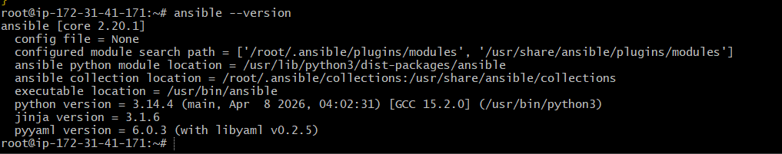

STEP 6 — Create Inventory File
On master:
mkdir -p /etc/ansible
cd /etc/ansible
nano /etc/ansible/hosts

Create inventory:
Add:
[all]
172.31.40.75
172.31.36.231
Save file.

STEP 7— Generate SSH Key on Master
On Master:
ssh-keygen
Press ENTER for all prompts.
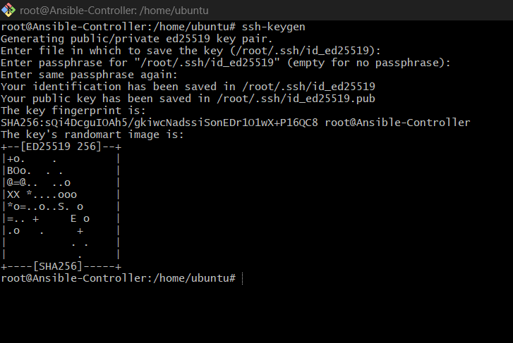
Keys created:
~/.ssh/id_rsa
~/.ssh/id_rsa.pub
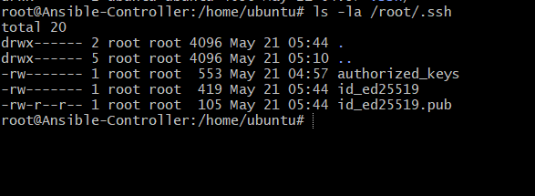
Run:
cat /root/.ssh/id_ed25519.pub
ssh-ed25519 AAAAC3NzaC1lZDI1NTE5AAAAINlg8d9c6eVdlVJ6DaxX6GpgcAaQwSa/cxdurH8grCzB root@Ansible-Controller
Copy the full output.
Then login to worker node and paste into:
mkdir -p ~/.ssh
nano ~/.ssh/authorized_keys
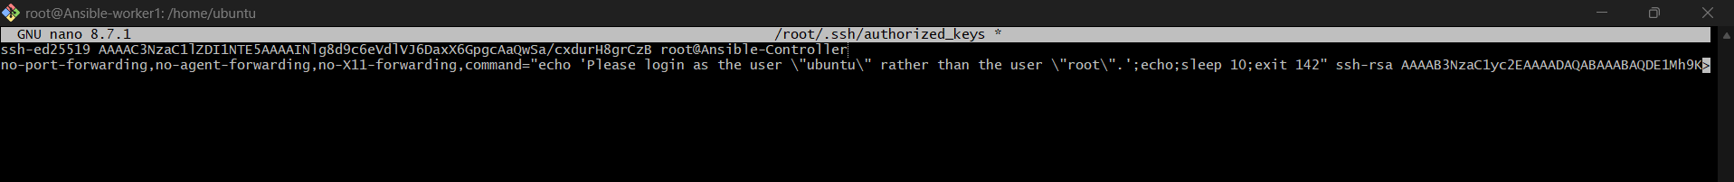
Paste key → save.
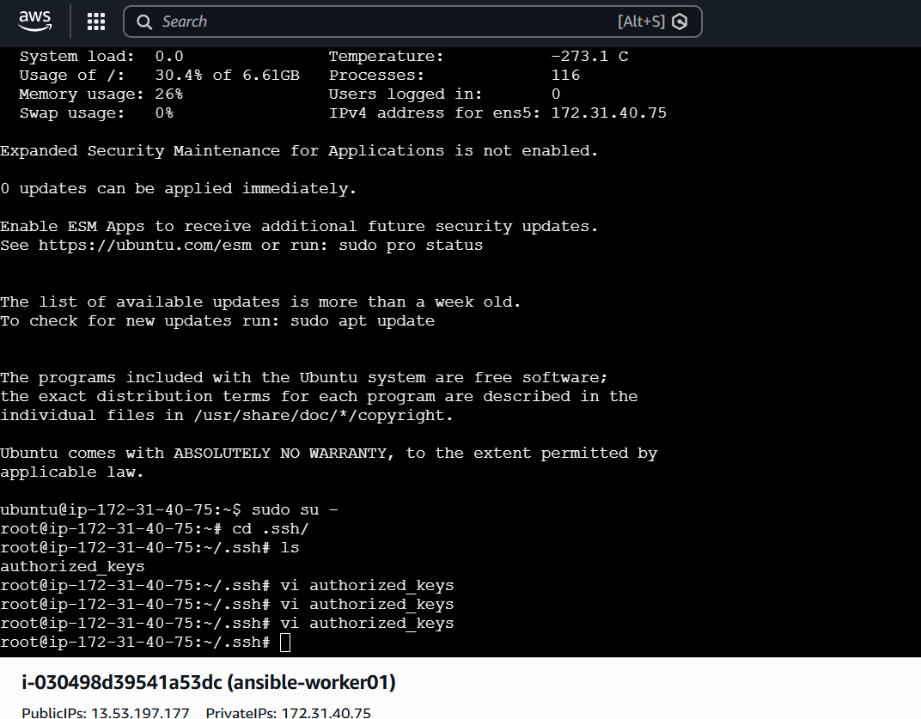
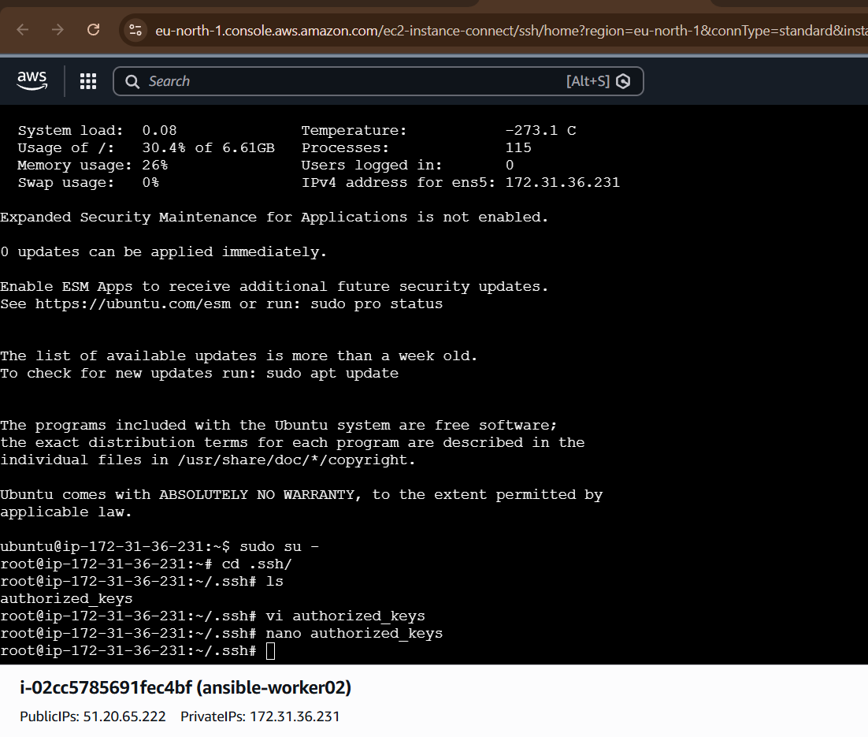

STEP 8 — Verify Passwordless SSH
From master:
ssh ansible@172.31.10.11
Then:
exit
Again:
ssh ansible@172.31.10.12
If login happens without password → success.
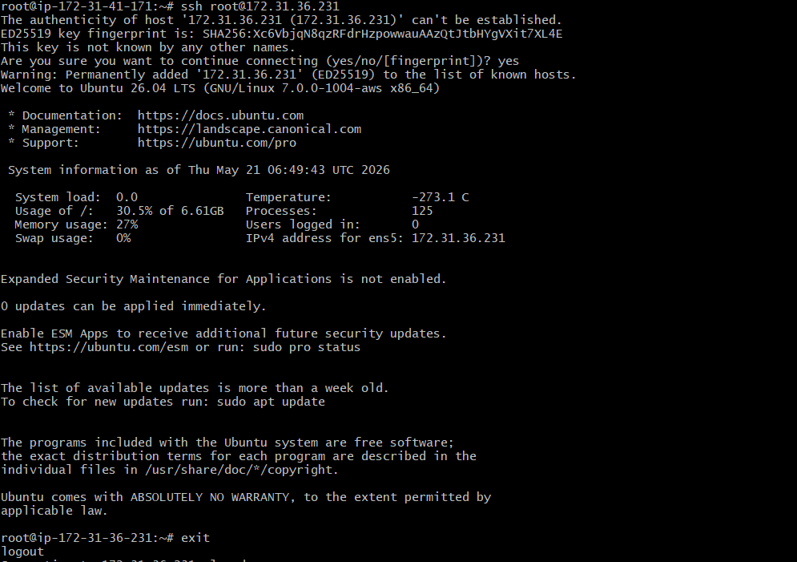

STEP 9 — Test Connectivity
Run:
ansible all -m ping
Expected output:
worker1 | SUCCESS => {
"changed": false,
"ping": "pong"
}
worker2 | SUCCESS => {
"changed": false,
"ping": "pong"
}
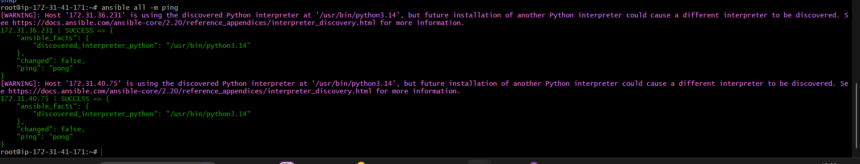

Final Folder Structure
ansible-project/
├── hosts
├── install-nginx.yml

Important Real-Time Commands
Check inventory
ansible-inventory -i hosts --list
Gather facts
ansible workers -i hosts -m setup
Restart nginx
ansible workers -i hosts -b -a "systemctl restart nginx"

Common Errors & Fixes
1. Permission denied
Fix:
chmod 400 key.pem
OR copy SSH key again.

2. Host key verification failed
Run:
ssh-keygen -R 172.31.10.11
ssh-keygen -R 172.31.10.12

3. UNREACHABLE
Check:
- Security Group
- SSH service
- IP address
- SSH key

Real-Time Industry Flow
Master Node
↓
Inventory File
↓
SSH Connection
↓
Worker Nodes
↓
Tasks/Playbooks Execution

2) Execute the adhoc command shared in #dvps-cloud-documents

1. Check Connectivity Between Slave Nodes
ansible all -m ping
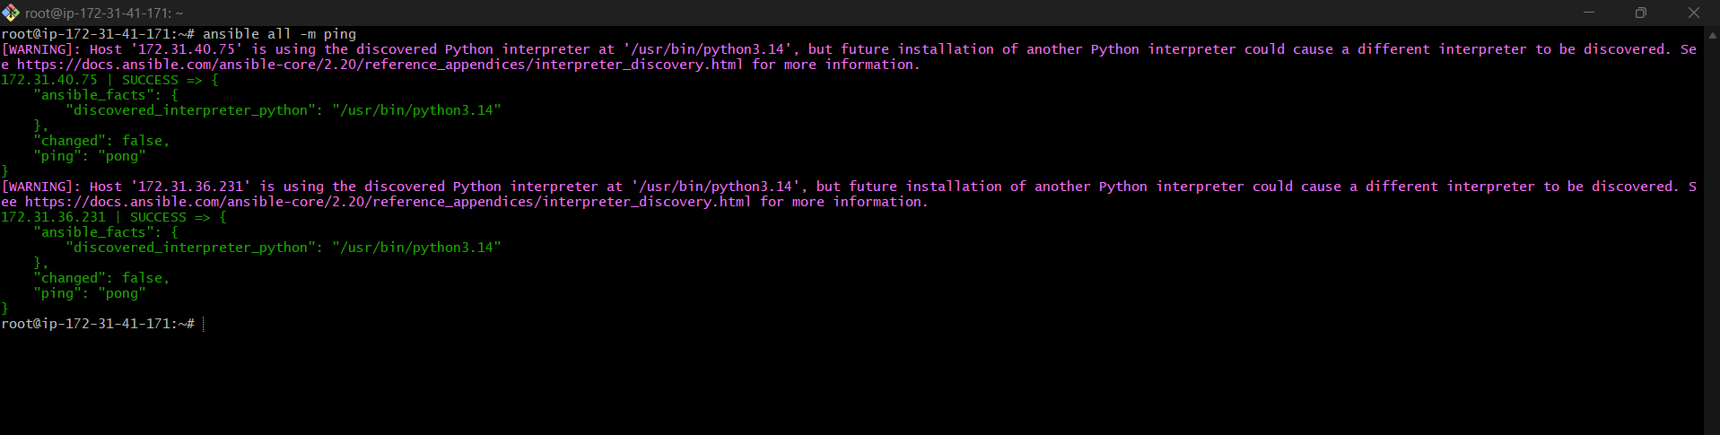
Using custom inventory:
ansible all -m ping -i ansible_hosts
Explanation
- all → all managed hosts
- -m ping → uses ping module
- -i → specify inventory file
Expected Output:
host1 | SUCCESS => {
"ping": "pong"
}

2. Gather Facts of Slave Machines
ansible all -m setup
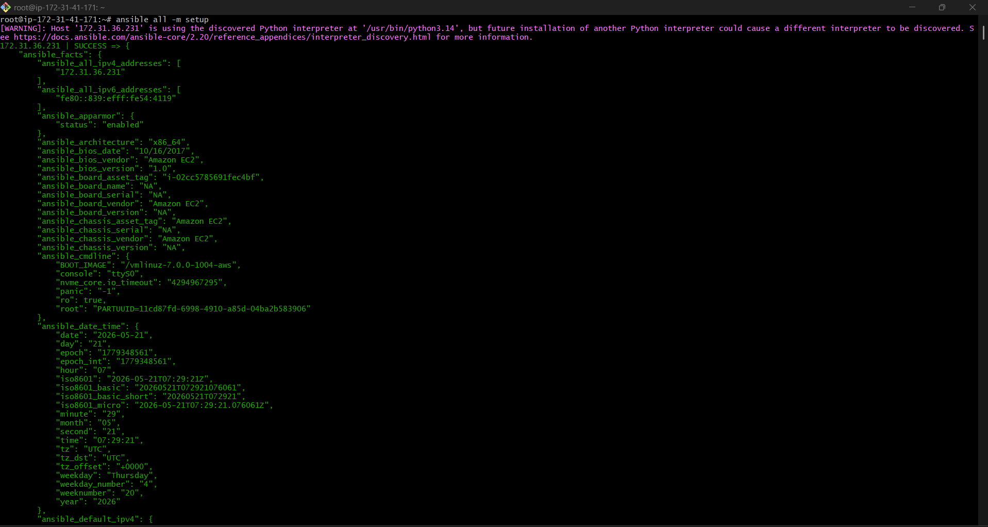
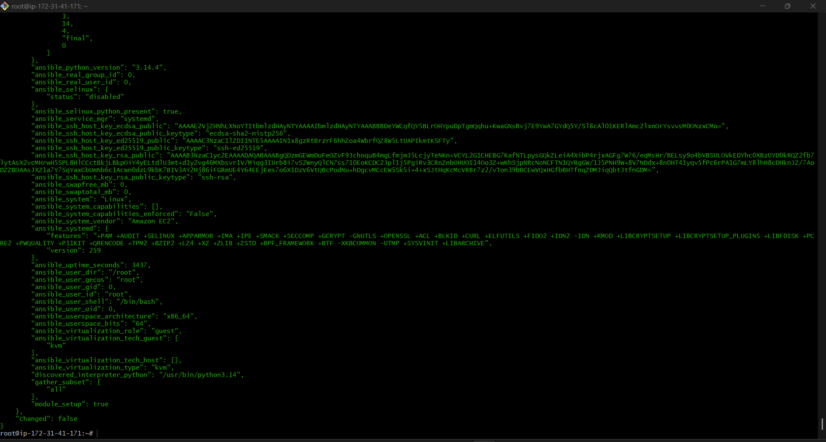
Purpose
Collects system information like:
- IP address
- OS version
- Memory
- CPU
- Hostname
- Disk details

3. Login Using Username & Password (Without SSH Key)
Login to Worker Node Using Ubuntu User
From master:
ssh ubuntu@172.31.40.75
Then second node:
ssh ubuntu@172.31.36.231

Create ansadm User
Run:
sudo adduser ansadm
Set password.
Give sudo permission:
sudo usermod -aG sudo ansadm

Enable Password Authentication
Open SSH config:
sudo vi /etc/ssh/sshd_config
Change:
PasswordAuthentication no
to:
PasswordAuthentication yes
Also ensure:
UsePAM yes
KbdInteractiveAuthentication yes

Step 4: Restart SSH
sudo systemctl restart ssh
Run
ansible all -m ping --user=ansadm --ask-pass
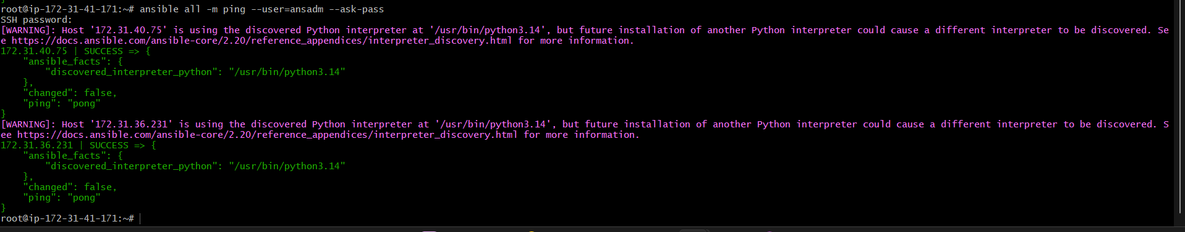
Explanation
- --user → remote username
- --ask-pass → prompts SSH password

4. Check Uptime of Slave Machines
ansible all -a uptime
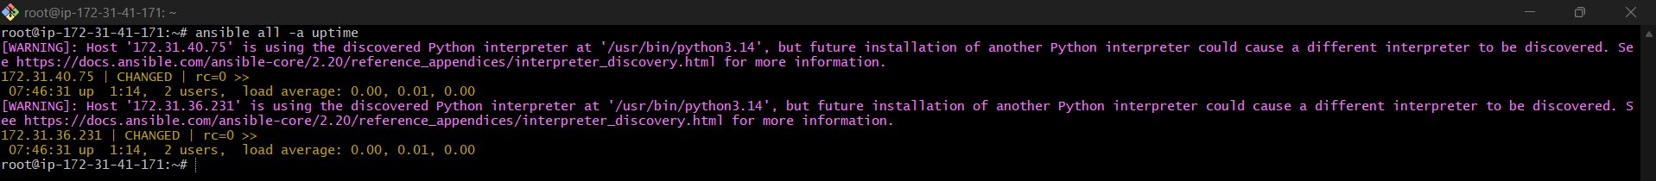
Tips
- -a → argument
- Runs command module by default

5. Check Free Memory / RAM Usage
ansible all -a "free -m"
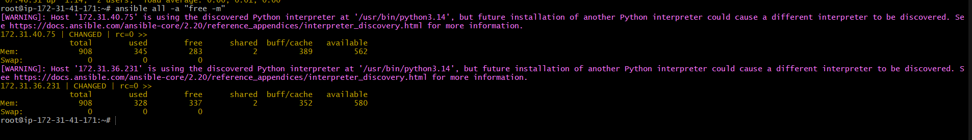

Output
Shows:
- Total RAM
- Used memory
- Free memory

6. Execute Command as Root User (sudo)
ansible all -m shell -a "cat /etc/passwd | grep -i ansadm" -b -K
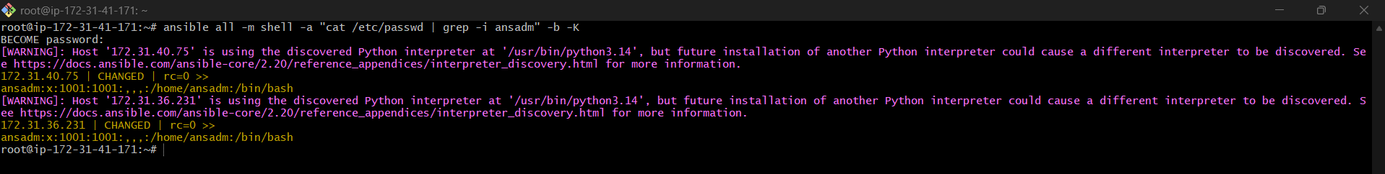
Explanation
Old Option | New Option
-s | -b
--ask-sudo-pass | -K

Meaning
Option | Purpose
-b | become (sudo)
-K | ask sudo password

7. Execute Command Using Become
ansible all -m shell -a "cat /etc/passwd | grep -i ansadm" -b -K
Explanation
- -b → become
- -K → ask become/sudo password
Modern recommended syntax.
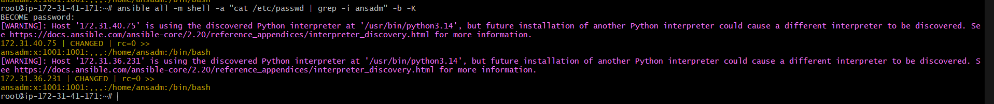

8. Execute Command as Different User
ansible all -m file -a "path=/home/ansadm/test state=directory mode=0755" -b --become-user=ansadm
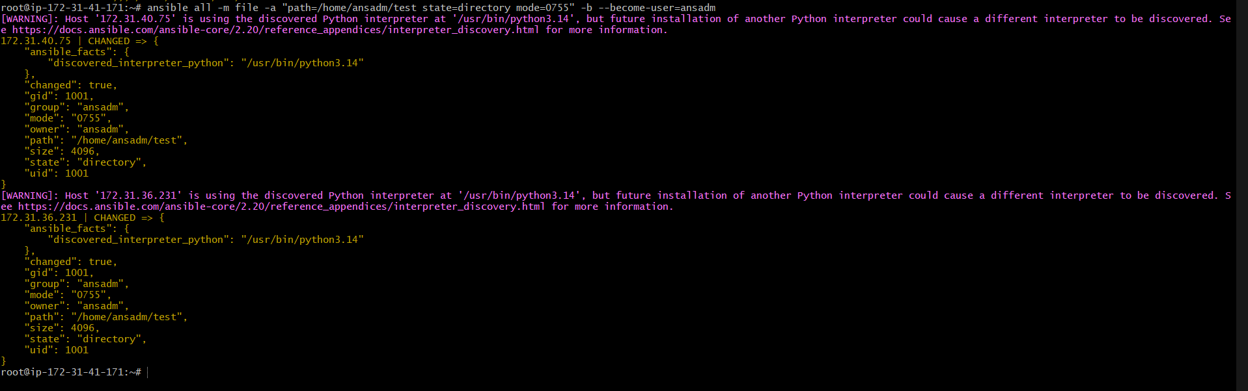
Purpose
Creates directory as another user.

9. Create Linux Group
ansible all -m group -a "name=test state=present" -b -K
Explanation
- group module manages Linux groups
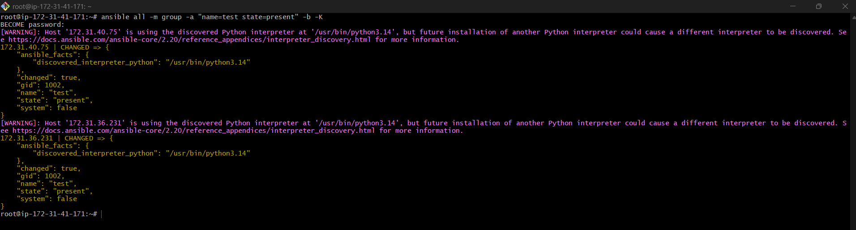

10. Create File with Permission
ansible all -m file -a "path=/home/ansadm/testfile state=touch mode=0755"
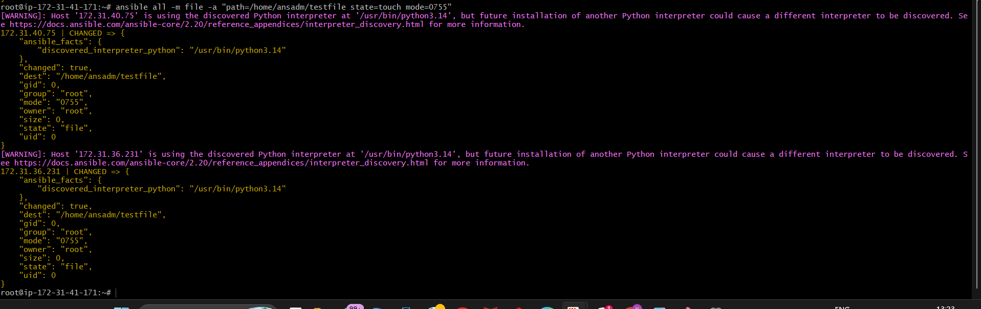
Purpose
Creates empty file with permissions.

11. Change Ownership of File
ansible all -m file -a "path=/home/ansadm owner=weblogic group=weblogic" -b
Step 1: Create Group
ansible all -m group -a "name=weblogic state=present" -b
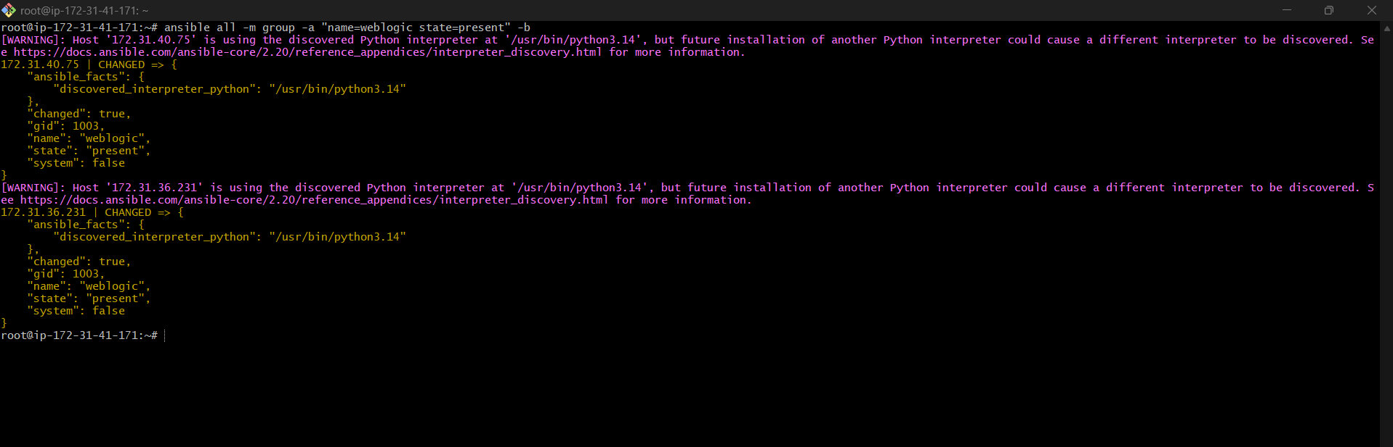

Step 2: Create User
ansible all -m user -a "name=weblogic group=weblogic state=present" -b
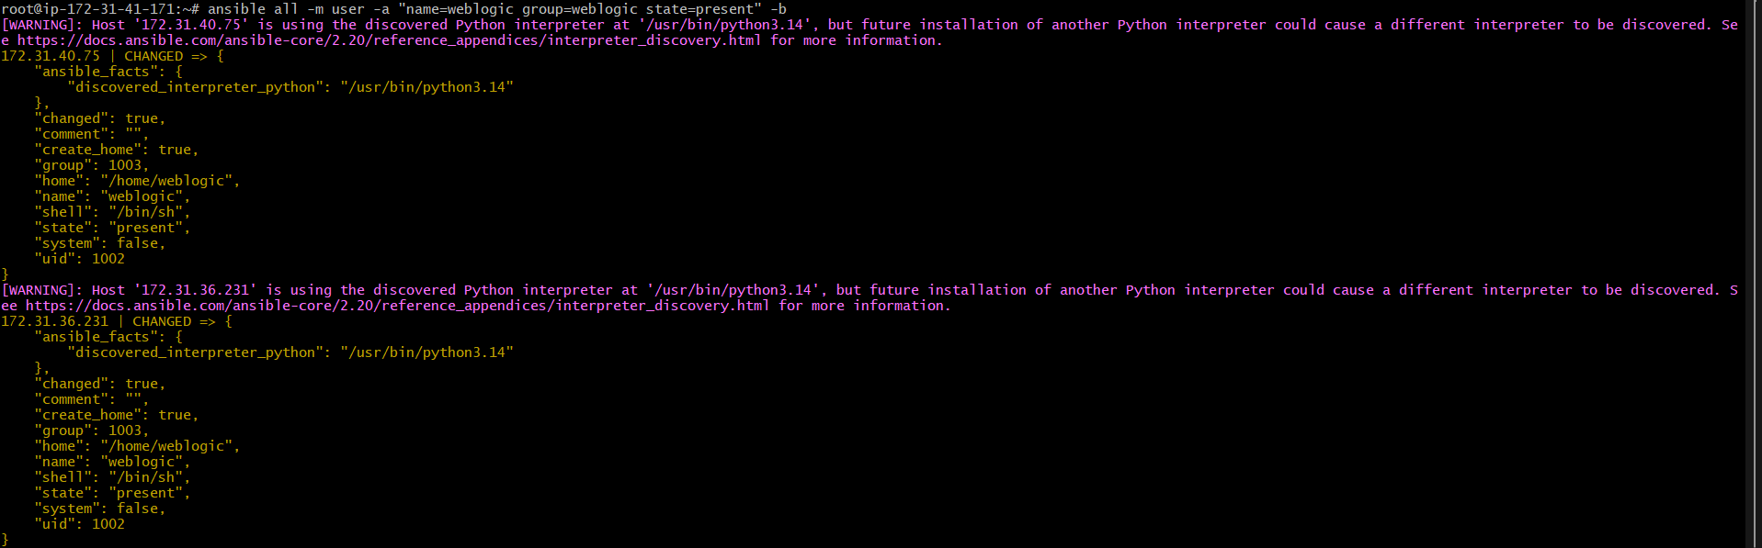

Step 3: Verify User
ansible all -m shell -a "id weblogic"
Expected:
uid=1002(weblogic) gid=1002(weblogic)
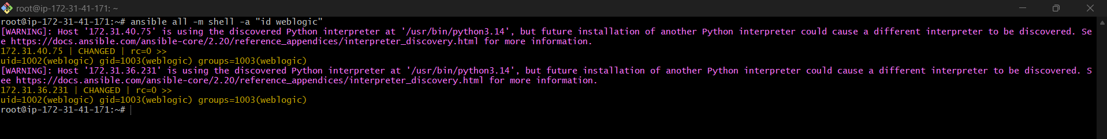

Step 4: Run Ownership Command Again
ansible all -m file -a "path=/home/ansadm owner=weblogic group=weblogic" -b
Now it will work.
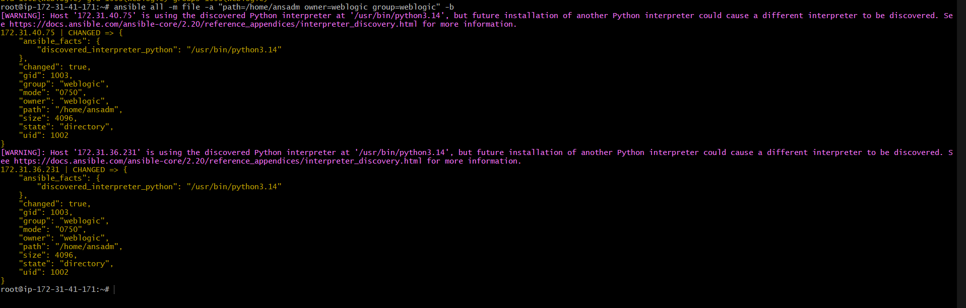

ansible all -m file -a "path=/home/ansadm owner=ansadm group=ansadm" -b
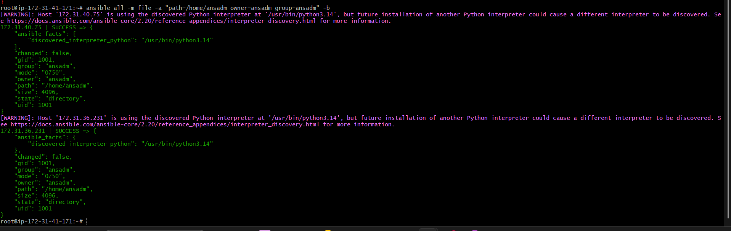

12. Install Package Using YUM
For RHEL/CentOS:
ansible all -m yum -a "name=httpd state=installed" -b
For Ubuntu:
ansible all -m apt -a "name=apache2 state=present" -b
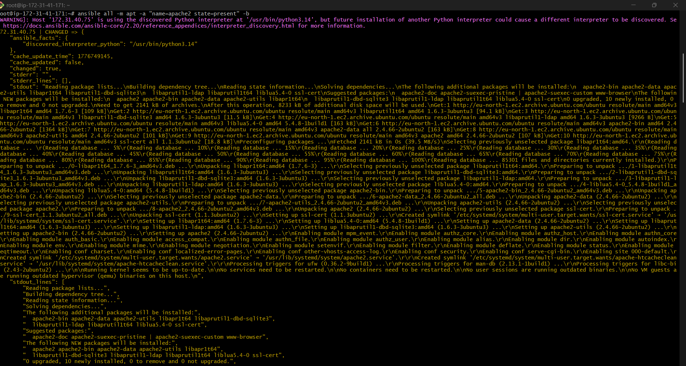
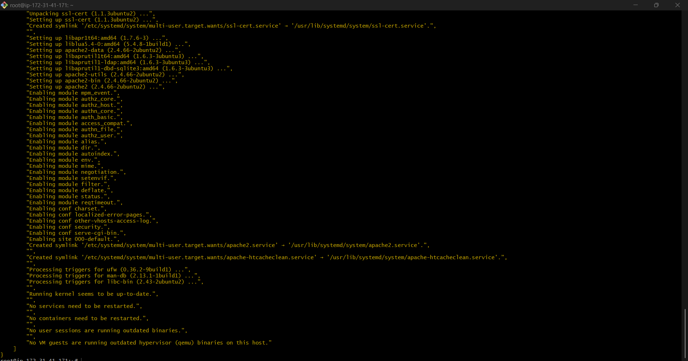

13. Start Service
ansible all -m service -a "name=httpd state=started enabled=yes" -b
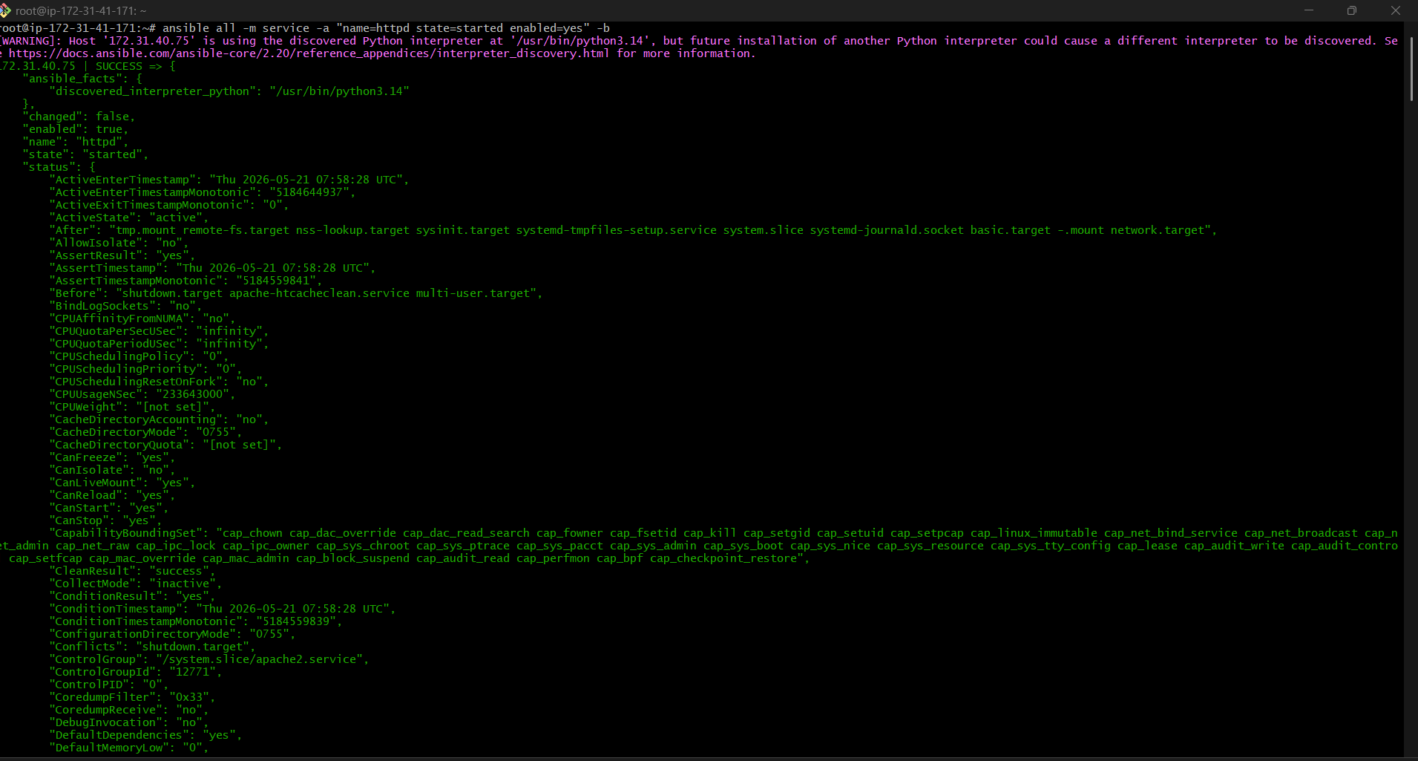
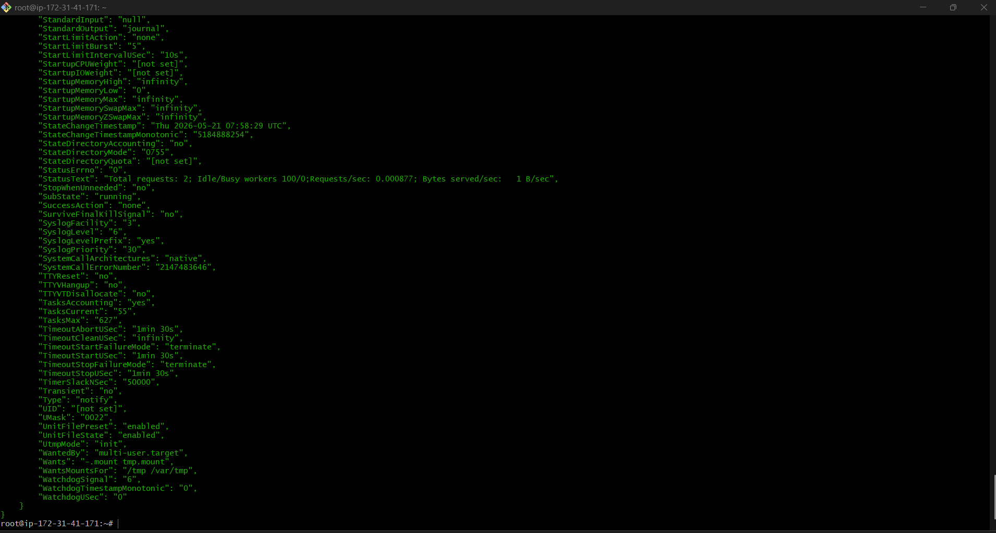
Explanation
- enabled=yes → starts on boot

14. Stop Service
ansible all -m service -a "name=httpd state=stopped enabled=yes" -b
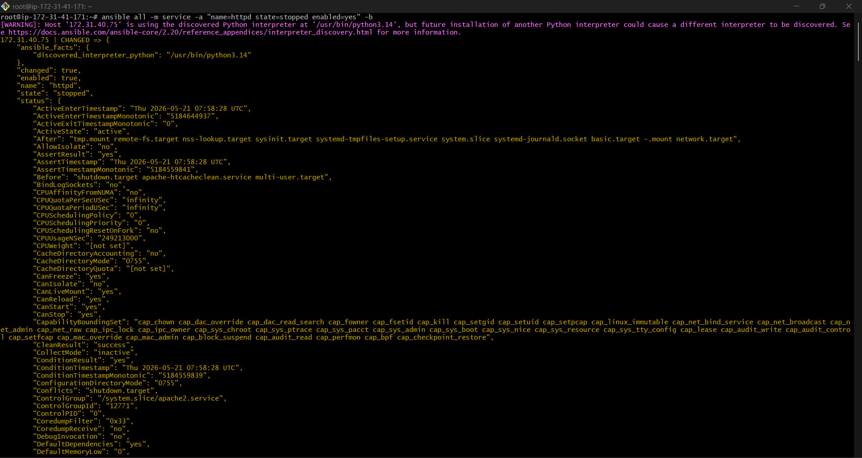
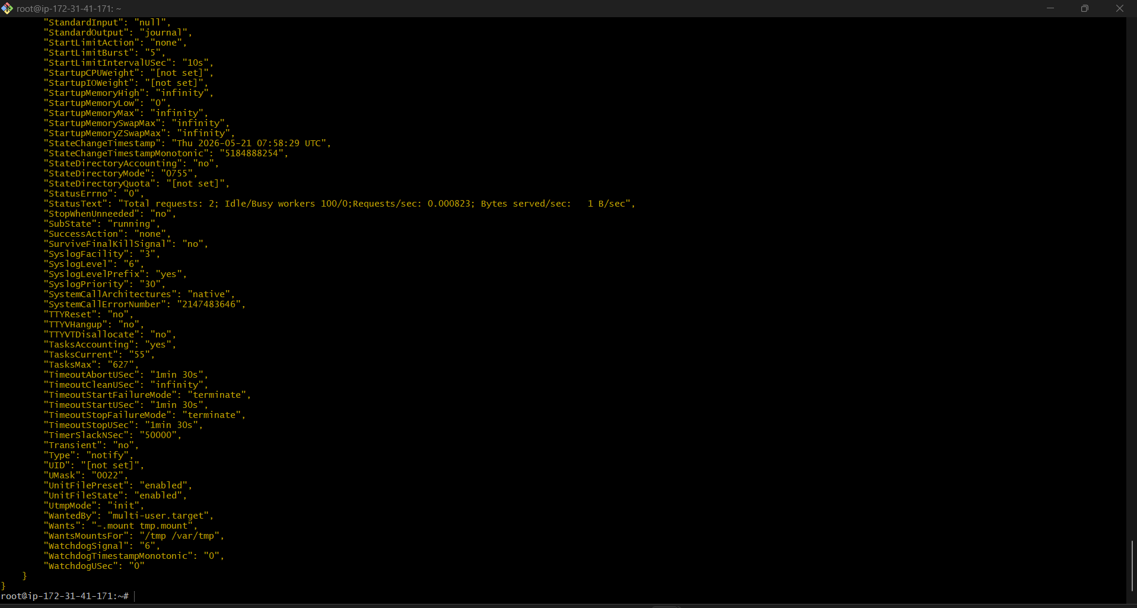
You wrote stop → correct value is stopped

Important
Option | Meaning
-m | Module
-a | Arguments
-i | Inventory file
-b | Become (sudo)
-K | Ask sudo password
--user | Remote username
--ask-pass | Ask SSH password

Most Important Modules
Module | Purpose
ping | Connectivity
setup | Gather facts
shell | Run shell commands
command | Run Linux commands
yum | Install packages in RHEL
apt | Install packages in Ubuntu
service | Manage services
file | Create/manage files
user | Manage users
group | Manage groups

